Instructions for completing a Fillable PDF form Please review the following instructions for successfully completing the fillable PDF form:
• Important: You need to save the document to your computer before filling it out. Do not complete the form online within your web browser, your data will NOT be saved. To save it, either right click with your mouse and click “Save As” and save it to your computer. Or click the download arrow in the top right hand corner and download the document to your computer.
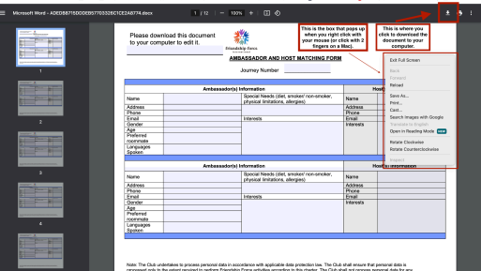
• Use only the latest version of Adobe Reader to complete fillable PDF forms. Macintosh and Windows versions of the free Adobe Reader are available from Adobe at
http://get.adobe.com/reader/.
• Once you have saved the form to your computer, you are ready to complete the form. • Open the form.
• After you have completed the form, save a final version of the file to your computer. • You can then attach the document to an email message to send to the journey coordinator.

HOST APPLICATION AND AGREEMENT
A Friendship Force Journey offers an opportunity for people from different cultural backgrounds or traditions to share their lives with each other in the spirit of friendship. The success of the experience depends on the extent to which participants are welcoming of one another, willing to build friendships and promote mutual understanding, and able to maintain openness and flexibility in adapting to unforeseen situations.
The following information is needed to help the host coordinator match host families with ambassadors. Note: Only one application and agreement is needed for each household. This form should be used for club-to-club journeys or special journeys. A different form is required for hosting an independent journey.
General Host Information
1. Name:
2. Contact Information
(a) Address:
(b) Home Phone: |  | (c) Cell Phone: |  |  |  | (d) Email:
3. Have you participated in a Home Stay (or similar) before? Yes: ☐ No
4. Information of Household Members (including yourself):
Name | Relationship |  | Age | Gender | Occupation (or previous, if retired)
5. Please note any languages you speak other than your own and your proficiency (Excellent, Good, Fair, Poor)
Language: |  |  |  | Language:
6. Interests and Hobbies:
Housing Information
7. Please indicate the type of pets you have: ☐ Dog ☐ Cat ☐ Bird ☐ Other:
(a) Do the pets live primarily inside the house?
_{Yes No} Yes No
8. Are you willing to host smokers? Does anyone in your household smoke?
9. Number of Ambassadors you prefer to host:
(a) What type of Ambassadors would you prefer to host:
☐ Couple (married or unmarried) ☐ Family ☐ Female(s) ☐ Male(s) ☐ No Preference
(b) Special hosting requests
10. Please indicate how many beds are available for ambassadors:
Single Double Queen King
11. On what floor are the bedrooms located? (check all that apply) ☐ Ground Floor ☐ Upstairs
12. Are the bedrooms on the same floor as the bathroom? Is it shared? Yes No Yes No
Additional Questions
13. Journeys can often include a lot of driving. Would you be willing to use your car to drive ambassadors to the events? How many passengers can fit in your car (excluding the driver)?
14. If you are unable to host Ambassadors overnight, would you be willing to serve as a Day Host and participate in the daily activities of the journey?

15. Briefly tell us why you would like to be a host:

HOST AGREEMENT
The undersigned Applicant (on behalf of all members of the household, collectively called "I") agrees to participate in a citizens' journey program by serving as a Host for an international visitor or visitors. I recognize that this journey was arranged by Friendship Force International which includes its directors, officers, and employees, as well as its volunteers. I also recognize that there are certain risks in having people visit me and stay in my home, and I am willing to assume and bear these risks in order to meet and share experiences with someone from another country.
Therefore, in consideration of my selection by Friendship Force International as a Friendship Force Host for this journey, I do hereby release, indemnify and hold harmless Friendship Force International from all claims, actions, and causes of action based upon or by reason of any loss, damage or injury to any person or property of any member of the household, arising out of, or in any manner connected with, any aspect of the journey. As a Host, I shall:
a) Willingly accept in my home people who may be of another race or religious preference, who may not speak my language, and with whom I am unfamiliar
b) Provide room and board for a visiting Ambassador for the specified days and nights c) Involve this Ambassador in the daily activities of my family
d) Participate in all official functions that are planned for Hosts during the journey
e) Attend training workshops and participate in an interview, if requested
f) Accept that the journey is a public event and that photographs and Host’s name may be used by the local and national media and Friendship Force International in its publications
Host Pledge: I agree to be an Ambassador of Goodwill to the visitors I am hosting, knowing that the customs and language of those visitors may be different from my own. The purpose of this journey is to extend friendship to the citizens of another country.
Signature of Applicant Date
www.my.friendshipforce.org
Updated 3/18/2024

